**Big Ideas in Mastery: Coherence**

|  |
| --- |
| **Key Messages:**   1. Small steps are easier to take. 2. **Focussing on one key point each lesson** allows for deep and sustainable learning. 3. Certain images, techniques and concepts are **important pre-cursors** to later ideas. Getting the sequencing of these right is an important skill in planning and teaching for mastery. 4. When introducing new ideas it is important to make connections with earlier ones that have already been understood. 5. When something has been deeply understood and mastered, it can and should be **used in the next steps of learning**. |

**For example:**

Before teaching the expansion of 2 brackets:

Pupils need to:

* understand that a product of two elements where each element is made up of two parts can be shown as 4 partial products as in 43 × 24 = (40 + 3) × (20 + 4) = 40 × 20 + 40 × 4 + 3 × 20 + 3 × 4.
* be fluent in their number facts for multiplication
* be fluent in the addition, subtraction and multiplication of negative numbers
* be fluent in algebraic simplification (collecting like terms and multiplication)

Before teaching the written algorithm for division:

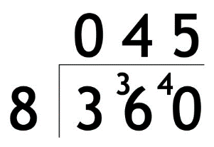

Pupils need to:

* Be aware that the format of the standard algorithm is an abstraction of the area image for multiplication but where the product and one factor are given and the other factor is to be found - i.e.

360

?

8

* Have a deep understanding of place value and know, for instance, that 360 can be partitioned in a number of different ways – i.e. 3 hundreds and 6 tens but also as 36 tens.
* Understand that, when dividing a number by 8 (or any other divisor), that number can be partitioned, each part divided by 8 and then the two quotients added together.
* Be fluent in the recall of simple division facts.
* Be fluent in grouping integer values leaving remainders – linking to the understanding that the remainder is still to be shared by the divisor.
* Understand that 360 divided by 8 is the same as 36 tens divided by 8 which is the same as 36 divided by 8 and then that number of tens.

**Personal reflection / action planning**

|  |
| --- |
| What is significant, relevant and/or important for me in this feature of teaching for mastery? |

|  |
| --- |
| What aspects of my own practice (and the practice of my department) are already embedded or being developed in this area? |

|  |
| --- |
| What aspects of my own practice (and the practice of my department) do I want to develop now? |

**Big Ideas in Mastery: Coherence**

|  |
| --- |
| **Key Messages:**   1. Small steps are easier to take. 2. **Focussing on one key point each lesson** allows for deep and sustainable learning. 3. Certain images, techniques and concepts are **important pre-cursors** to later ideas. Getting the sequencing of these right is an important skill in planning and teaching for mastery. 4. When introducing new ideas it is important to make connections with earlier ones that have already been understood. 5. When something has been deeply understood and mastered, it can and should be **used in the next steps of learning**. |

**For example:**

Before teaching how to solve a pair of simultaneous linear equations by elimination:

Pupils need to:

* solve linear equations with one unknown
* multiply algebraic expressions by an integer
* be fluent in the addition, subtraction, multiplication and division of positive and negative numbers
* be fluent in algebraic simplification (collecting like terms and multiplication)

When introducing the new idea of solving a pair of simultaneous linear equations, it is powerful for students to revisit finding pairs of numbers that satisfy an equation with two unknowns (National Curriculum Year 6 Programme of Study):

These problems lead to a discussion of possible solutions (from integers at first to all sets of numbers, with some prompting perhaps) – an “infinity” of solutions.

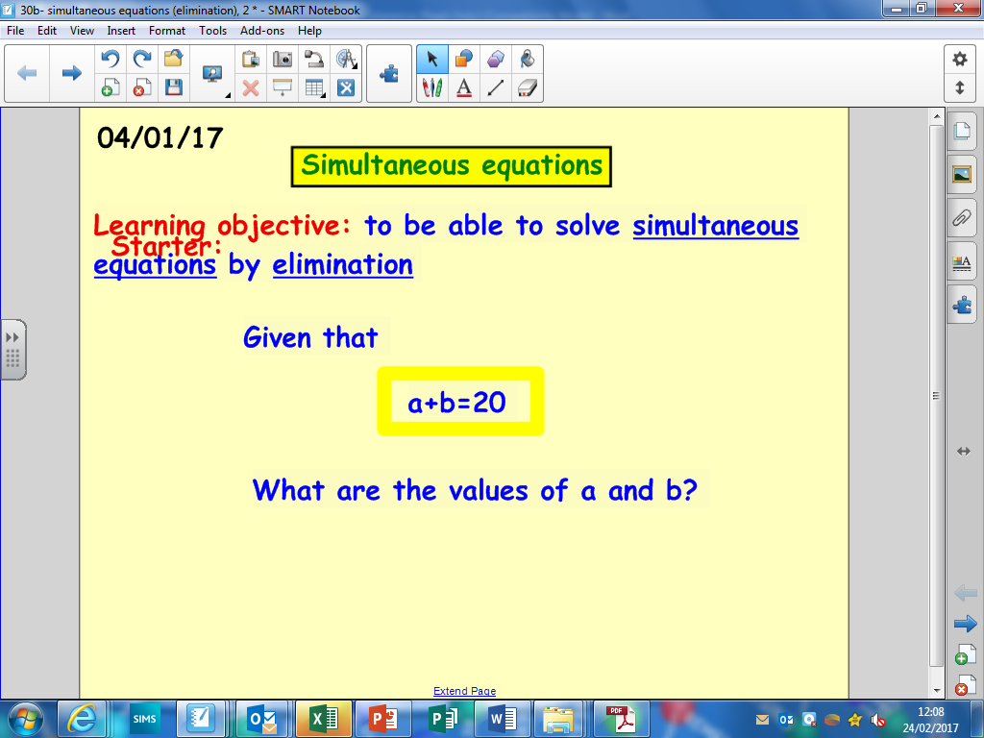

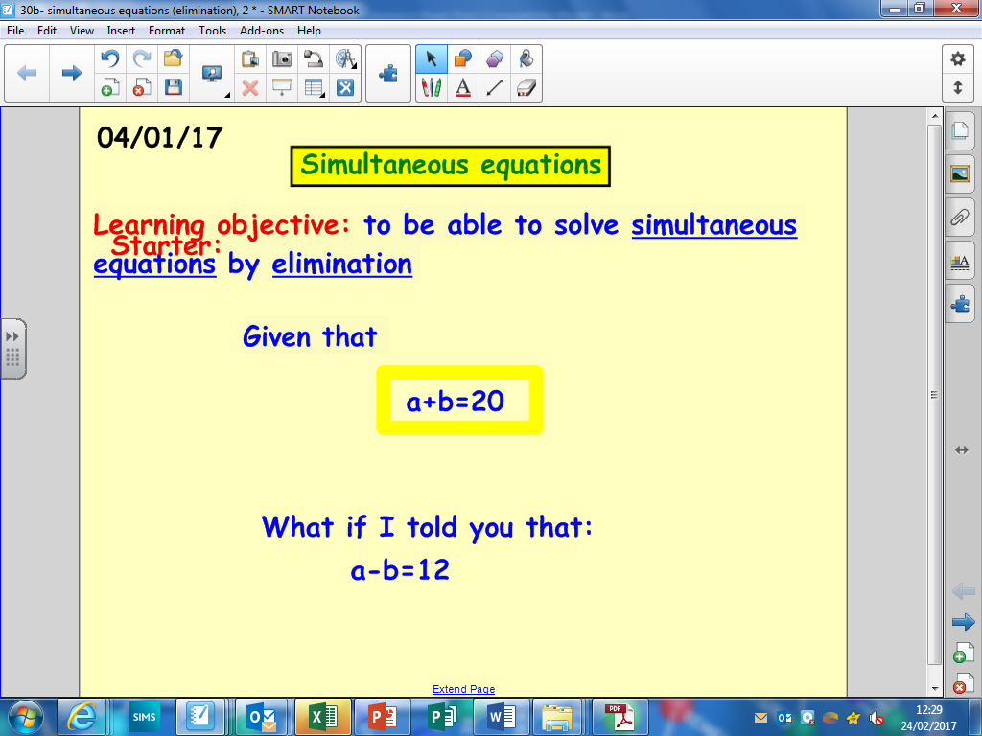If students are then asked to also consider a second equation, they realise the solution to both equations has to be the pair a=16 and b=4.

**Personal reflection / action planning**

|  |
| --- |
| What is significant, relevant and/or important for me in this feature of teaching for mastery? |

|  |
| --- |
| What aspects of my own practice (and the practice of my department) are already embedded or being developed in this area? |

|  |
| --- |
| What aspects of my own practice (and the practice of my department) do I want to develop now? |

**Big Ideas of Mastery: Fluency**

|  |
| --- |
| **Messages**   1. **Fluency demands more of learners than memorisation** of a single procedure or collection of facts. It encompasses **a mixture of efficiency, accuracy and flexibility**. 2. Quick and efficient recall of facts and procedures is important in order for learners’ to keep track of sub problems, think strategically and solve problems. 3. Fluency also demands the **flexibility to move between different contexts and representations of mathematics**, to recognise relationships and make connections and to make appropriate choices from a whole toolkit of methods, strategies and approaches. |

**For example:**

**Circles:** The 9 -1 GCSE Specification [(Mathematics: GCSE subject content and assessment objectives, DfE)](https://www.gov.uk/government/publications/gcse-mathematics-subject-content-and-assessment-objectives#GCSE) expects students to know and recall the formulae to calculate the circumference and area of a circle.

All students are also expected to calculate arc lengths, angles and areas of sectors for circles. It is important that students make connections with the circle formulae and understand the arc length is a proportion ( of the circumference and the sector area is the same proportion (of the area of the circle rather than the need to memorise additional formulae such as:

Fluency demands the flexibility to move between different contexts and to make connections; the conceptual understanding referred to here is crucial to that.

**Volume of a Pyramid:** The 9 -1 GCSE Specification 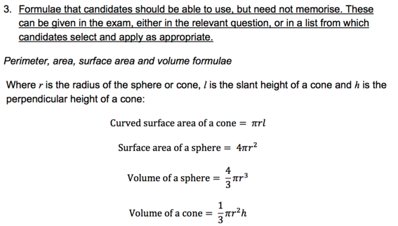 [(Mathematics: GCSE subject content and assessment objectives, DfE)](https://www.gov.uk/government/publications/national-curriculum-in-england-mathematics-programmes-of-study/national-curriculum-in-england-mathematics-programmes-of-study#year-3-programme-of-study) does not expect students to memorise the formula to calculate the volume of a cone. However, all students are expected to know how to calculate the volume of a pyramid (). Students are fluent when they appreciate the connections between these formulae rather than blindly memorising unconnected facts.

**Personal reflection / action planning**

|  |
| --- |
| What is significant, relevant and/or important for me in this feature of teaching for mastery? |

|  |
| --- |
| What aspects of my own practice (and the practice of my department) are already embedded or being developed in this area? |

|  |
| --- |
| What aspects of my own practice (and the practice of my department) do I want to develop now? |

**Big Ideas of Mastery: Fluency**

|  |
| --- |
| **Messages**   1. **Fluency demands more of learners than memorisation** of a single procedure or collection of facts. It encompasses **a mixture of efficiency, accuracy and flexibility**. 2. Quick and efficient recall of facts and procedures is important in order for learners’ to keep track of sub problems, think strategically and solve problems. 3. Fluency also demands the **flexibility to move between different contexts and representations of mathematics**, to recognise relationships and make connections and to make appropriate choices from a whole toolkit of methods, strategies and approaches. |

**For example:**

The 9 -1 GCSE Specification [(Mathematics: GCSE subject content and assessment objectives, DfE)](https://www.gov.uk/government/publications/gcse-mathematics-subject-content-and-assessment-objectives#GCSE) expects students to know recall key facts and formulae:

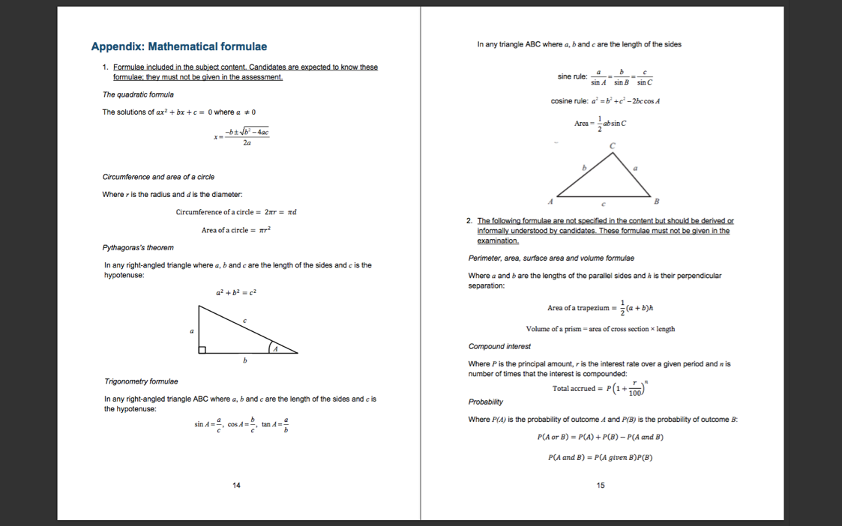

* Exact values of sinθ and cosθ for θ = 0º, 30º, 45º, 60º and 90º
* Exact value of tan*θ* for *θ =* 0º, 30º, 45º and 60º
* Graphs of linear functions, quadratic functions, simple cubic functions, the reciprocal function, **exponential functions *y*** = ***k x* for positive values of *k*, and the trigonometric functions (with arguments in degrees) *y*** = **sin*x*, *y*** = **cos*x* and *y*** = **tan*x* for angles of any size**
* **apply and prove the standard circle theorems concerning angles, radii, tangents and chords, and use them to prove related results**

**Personal reflection / action planning**

|  |
| --- |
| What is significant, relevant and/or important for me in this feature of teaching for mastery? |

|  |
| --- |
| What aspects of my own practice (and the practice of my department) are already embedded or being developed in this area? |

|  |
| --- |
| What aspects of my own practice (and the practice of my department) do I want to develop now? |

**Big Ideas in Mastery: Mathematical Thinking**

|  |
| --- |
| **Key Messages:**   1. Mathematical thinking is central to deep and sustainable learning of mathematics. 2. Taught ideas that are understood deeply are **not just ‘received’ passively but worked on by the student**. They need to be thought about, reasoned with and discussed. 3. Mathematical thinking involves:    1. looking for **pattern** in order to discern **structure**;    2. looking for **relationships** and **connecting ideas**;    3. **reasoning logically**, **explaining**, **conjecturing** and **proving**. |

**For example:**

There are some important general pedagogical strategies which support students’ mathematical thinking in all lessons:

* Encourage an atmosphere where asking questions, offering explanations, agreeing or disagreeing with others and giving reasons is encouraged and welcomed.
* Ask questions which encourage explanation, reasoning and proof like “why does this work?”; “can you draw a diagram to explain?”, “can you make up an example of your own?”, “what is the same and different about these examples?”, etc.
* Make use of learning journals (in class and for homework) where students are encouraged to make their own notes, create aide memoires for the important points in a topic or series of lessons and create their own worked examples with commentary.
* Move from simplistic teacher/pupil question and answer to a more dialogic teaching where active argument and debate is encouraged and where:
  + **interactions** encourage students to think, and to think in different ways
  + **questions** invite much more than simple recall
  + **answers** are justified, followed up and built upon rather than merely accepted as correct or rejected as incorrect
  + **exchanges** chain together into coherent and deepening lines of enquiry involving everyone
  + **discussion and argumentation** probe and challenge rather than unquestioningly accept

More specific activities that will encourage mathematical thinking include:

* Classifying mathematical objects - learners devise their own classifications for mathematical objects, and apply classifications devised by others.
* Interpreting multiple representations - learners match cards showing different representations of the same mathematical idea.
* Evaluating mathematical statements - learners decide whether given statements are ‘always true’, ‘sometimes true’ or ‘never true’.
* Creating problems - learners devise their own problems or problem variants for other learners to solve.
* Analysing reasoning and solutions - learners compare different methods for doing a problem, organise solutions and/or diagnose the causes of errors in solutions.

For examples of these activity types see section 4 (‘The types of activity’) in ‘Improving learning in mathematics: challenges and strategies, by Malcolm Swan, University of Nottingham - <https://www.ncetm.org.uk/public/files/224/improving_learning_in_mathematicsi.pdf>

**Personal reflection / action planning**

|  |
| --- |
| What is significant, relevant and/or important for me in this feature of teaching for mastery? |

|  |
| --- |
| What aspects of my own practice (and the practice of my department) are already embedded or being developed in this area? |

|  |
| --- |
| What aspects of my own practice (and the practice of my department) do I want to develop now? |

|  |
| --- |
| **Key Messages:**   1. The representation needs to clearly show the concept being taught, and in particular the key difficulty point. **It exposes the structure**. 2. In the end, the **students need to be able to do the maths without the representation** 3. A stem sentence describes the representation and helps the students move to working in the abstract (“ten tenths is equivalent to one whole”) and could be seen as a representation in itself 4. There will be some key representations which the students will meet time and again 5. **Pattern and structure are related but different**: Students may have seen a pattern without understanding the structure which causes that pattern |

**Big Ideas in Mastery: Representation & Structure**

**For example:**

Students will be familiar with the array to represent multiplication e.g.3 × 4 and 4 × 3

When this representation is extended to larger numbers and non-integers a more generalised ‘area’ model can be used to represent multiplication with the lengths of the sides of the rectangle able to take any value.

With the dimensions of the rectangle as 1 (essentially each dimension being a number line going from 0 to 1) a meaningful representation of the multiplication of fractions can be offered to students:

0

1

1

The representation reveals the structure and gives the student a tool to think with and to make sense of the various rules associated with the multiplication of fractions, hence avoiding ‘rules without reason’.

**Personal reflection / action planning**

|  |
| --- |
| What is significant, relevant and/or important for me in this feature of teaching for mastery? |

|  |
| --- |
| What aspects of my own practice (and the practice of my department) are already embedded or being developed in this area? |

|  |
| --- |
| What aspects of my own practice (and the practice of my department) do I want to develop now? |

**Big Ideas in Mastery: Representation & Structure**

|  |
| --- |
| **Key Messages:**   1. The representation needs to clearly show the concept being taught, and in particular the key difficulty point. **It exposes the structure**. 2. In the end, the **students need to be able to do the maths without the representation** 3. A stem sentence describes the representation and helps the students move to working in the abstract (“ten tenths is equivalent to one whole”) and could be seen as a representation in itself 4. There will be some key representations which the students will meet time and again 5. **Pattern and structure are related but different**: Students may have seen a pattern without understanding the structure which causes that pattern |

**For example:**

Use of algebra area tiles representing x2, x and 1 provide students with a tool to think with, manipulate and represent quadratics in the form ax2 + bx + c.

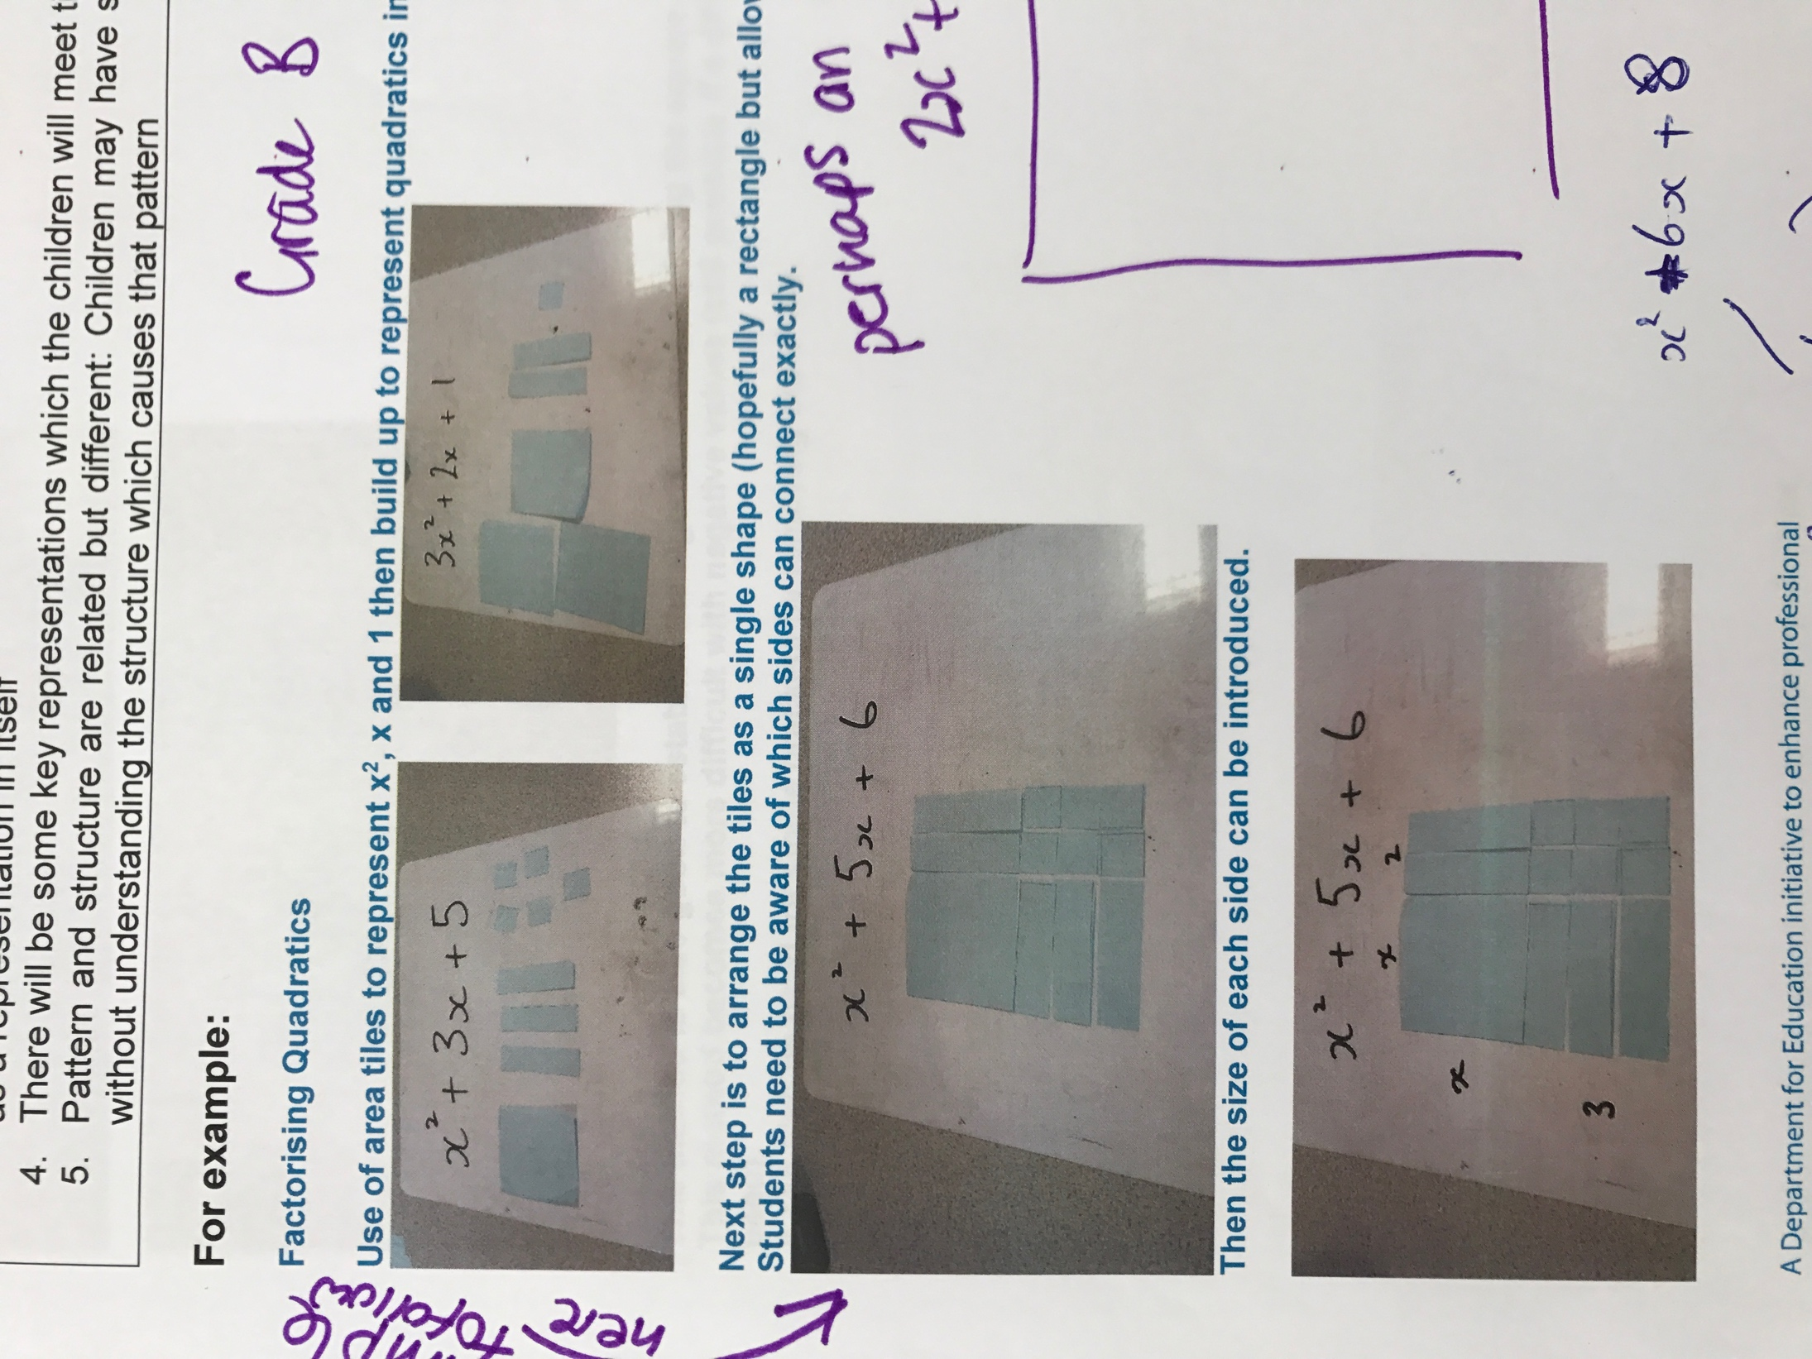

**Factoring Quadratics:**

The tiles support students to make sense of the various rules associated with factorising 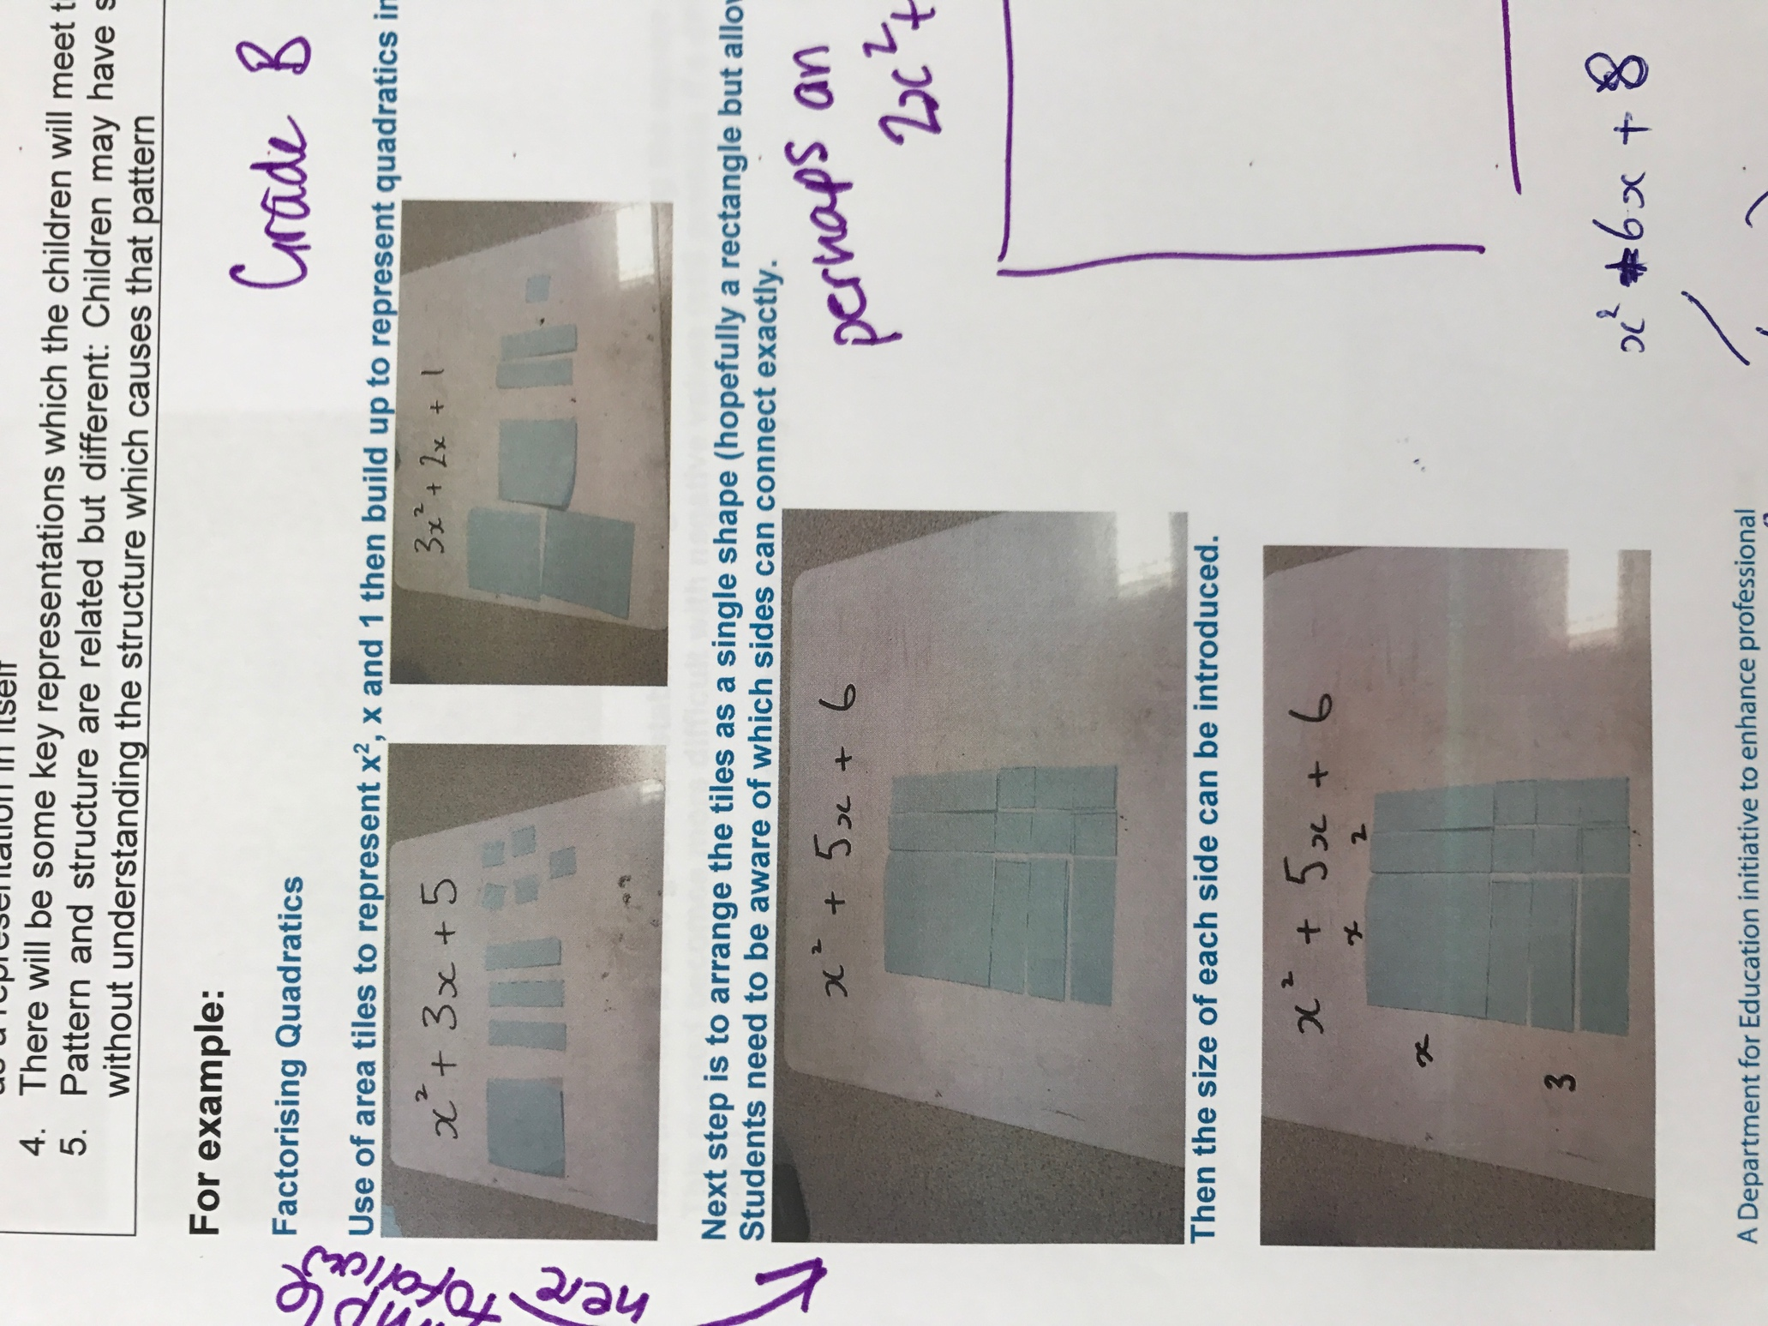quadratic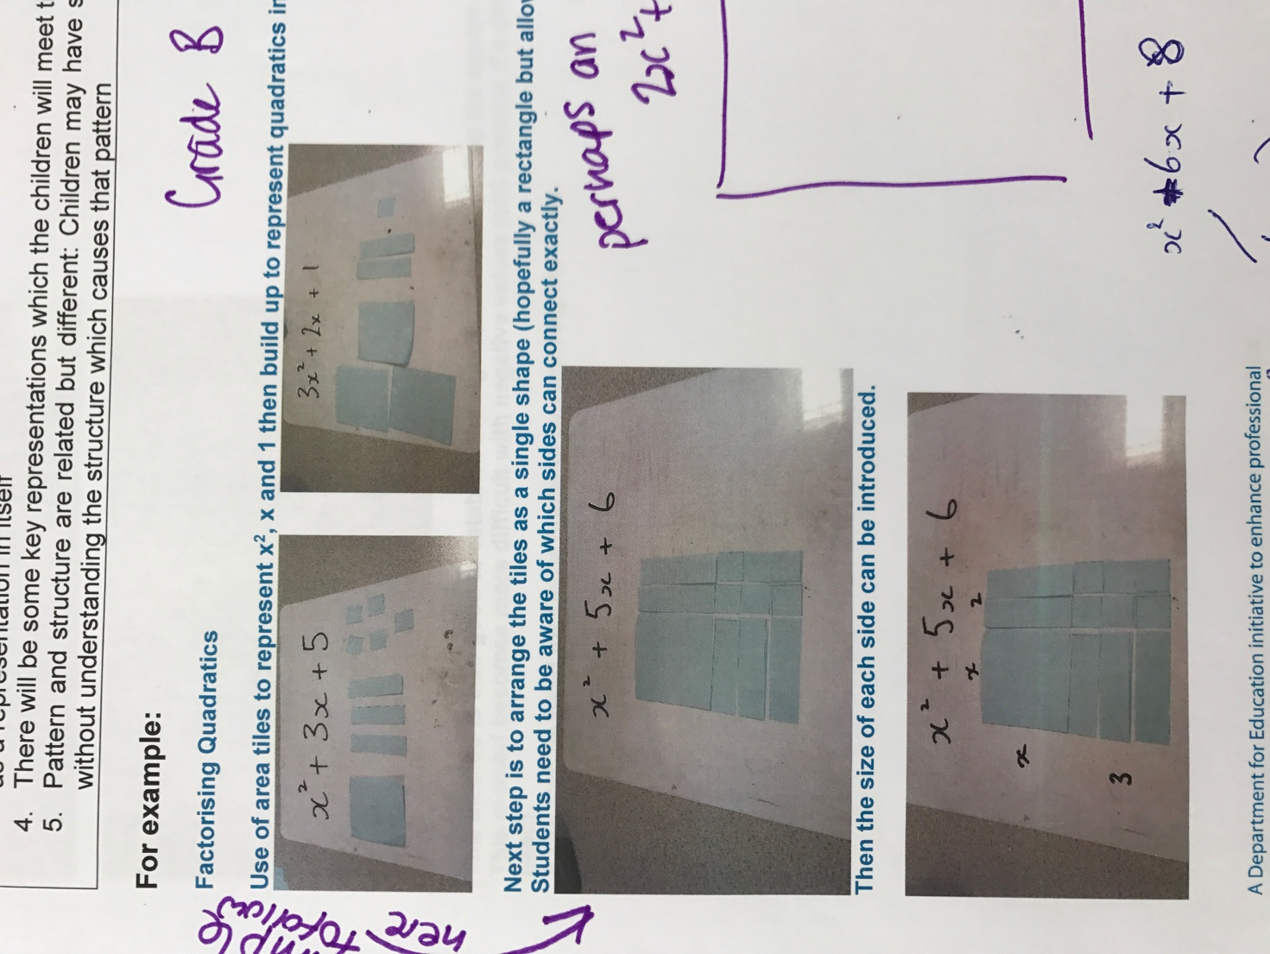s rather than remembering through spotting patterns or following rules blindly.

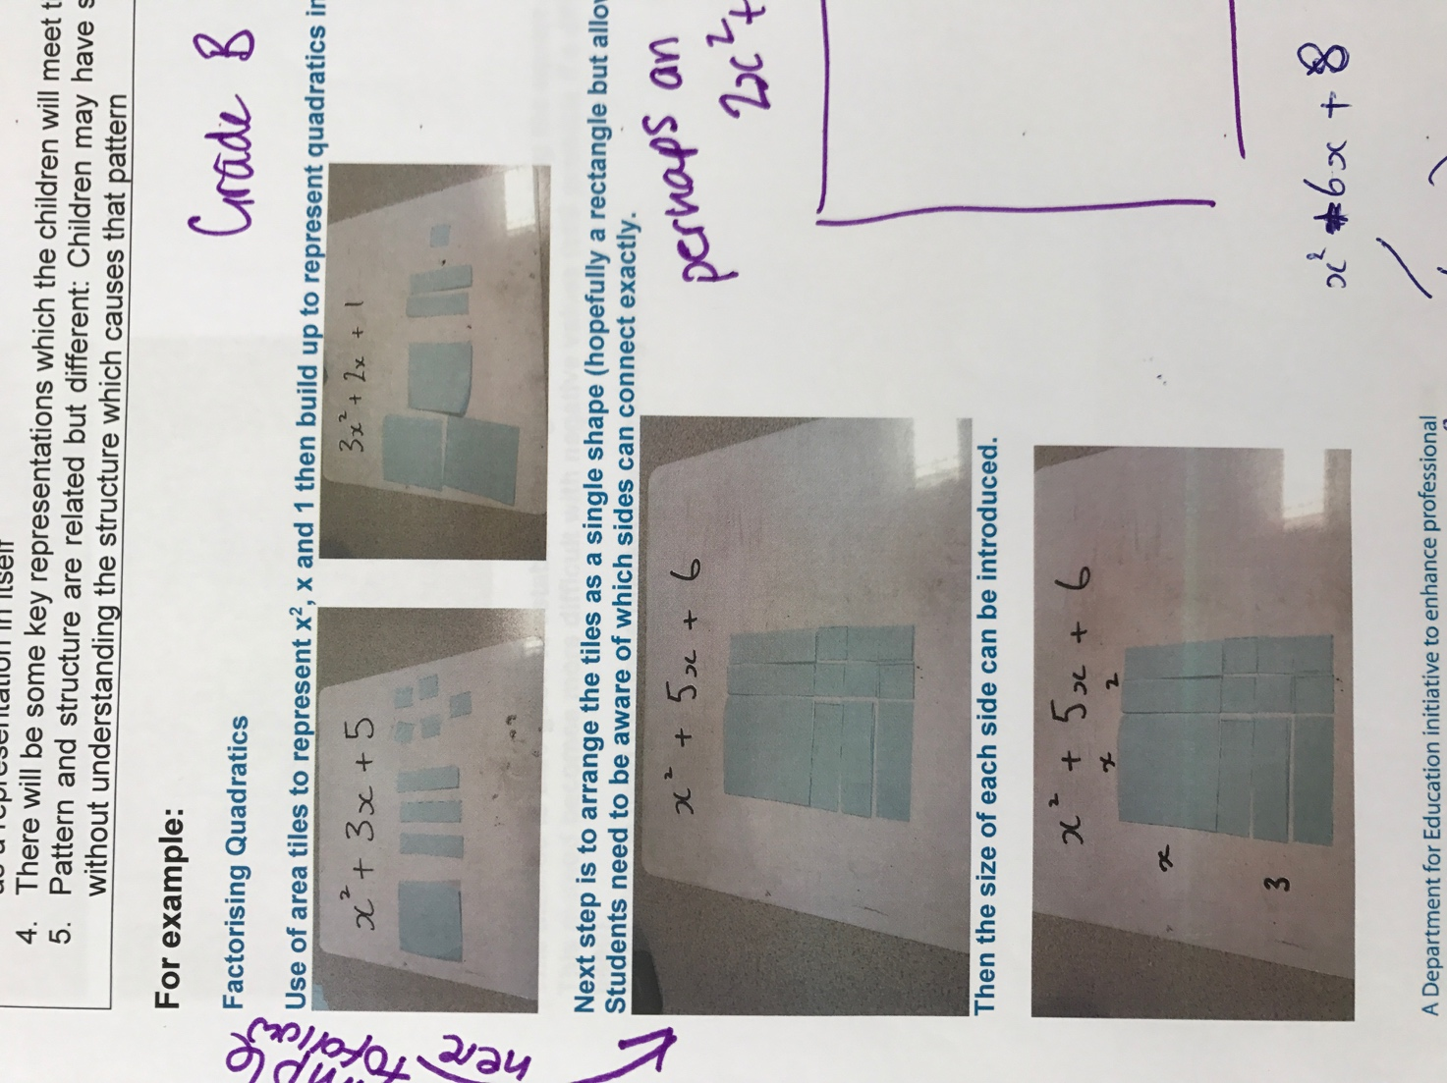

**Solving Quadratics:**

The tiles help students move to work in the abstract.

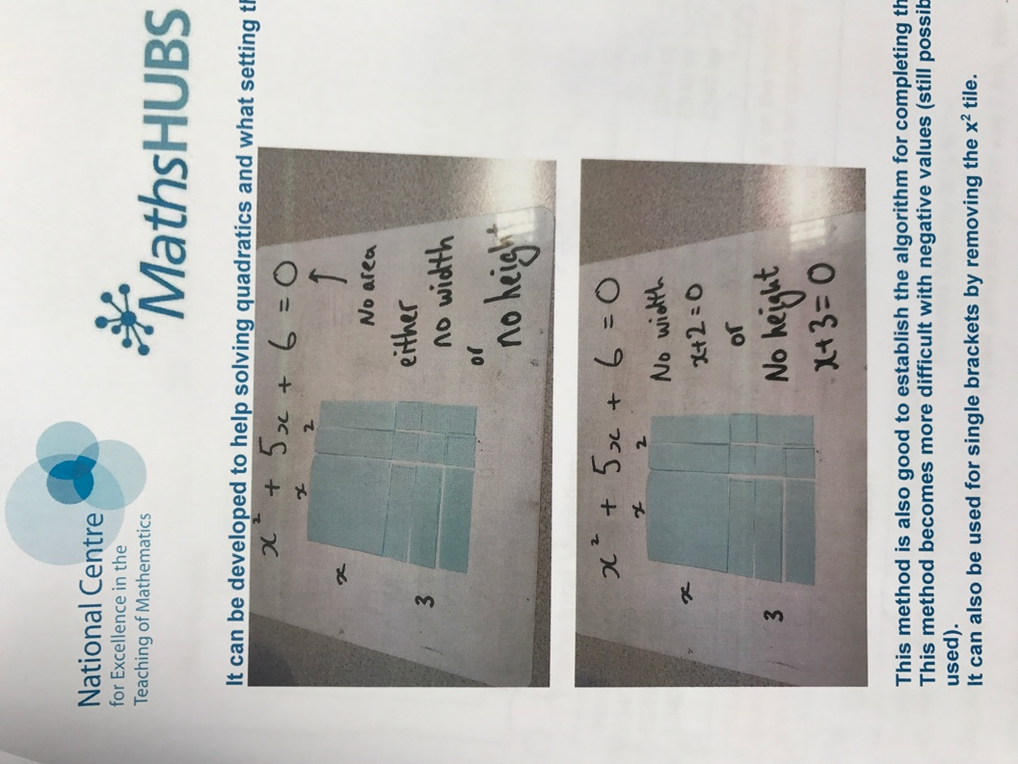

**Completing the Square:**

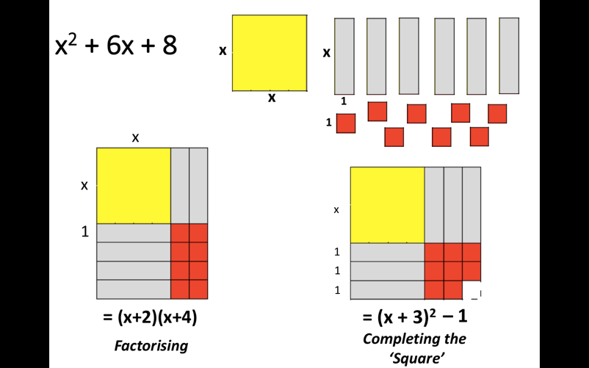

The tiles help reveal the ‘square’ structure.

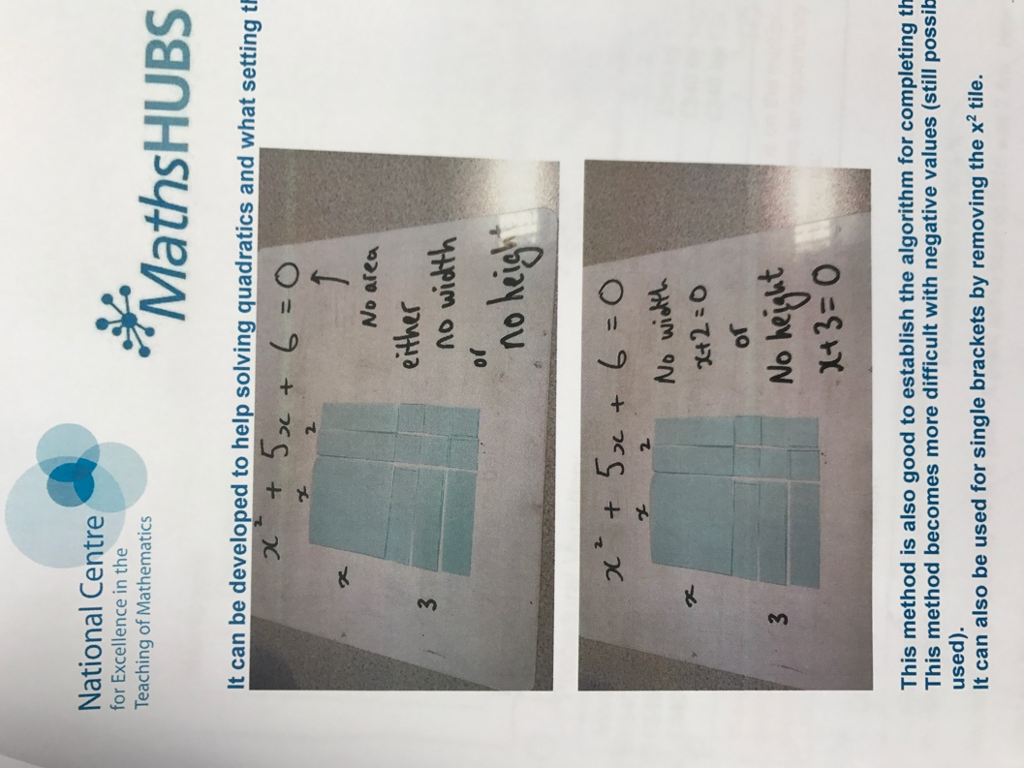

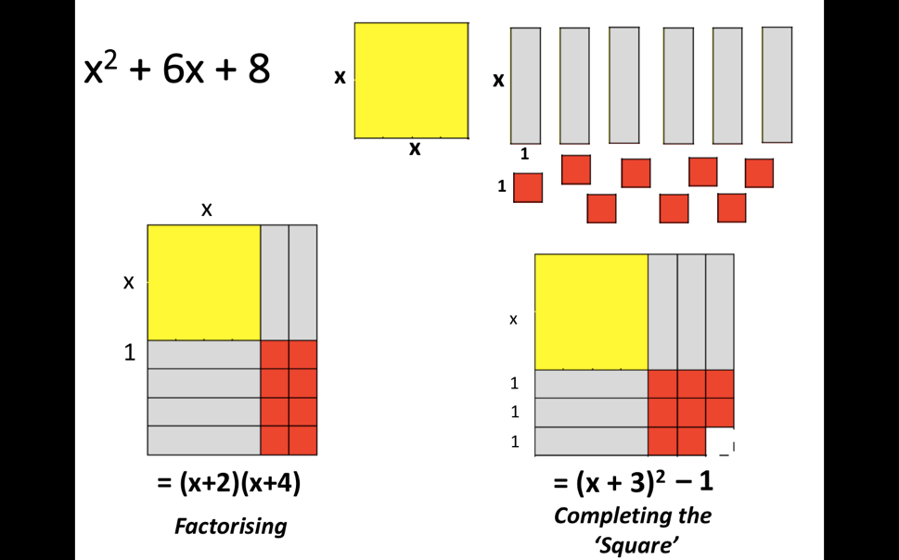

**Personal reflection / action planning**

|  |
| --- |
| What is significant, relevant and/or important for me in this feature of teaching for mastery? |

|  |
| --- |
| What aspects of my own practice (and the practice of my department) are already embedded or being developed in this area? |

|  |
| --- |
| What aspects of my own practice (and the practice of my department) do I want to develop now? |

**Big Ideas in Mastery: Representation & Structure**

|  |
| --- |
| **Key Messages:**   1. The representation needs to clearly show the concept being taught, and in particular the key difficulty point. **It exposes the structure**. 2. In the end, the **students need to be able to do the maths without the representation** 3. A stem sentence describes the representation and helps the students move to working in the abstract (“ten tenths is equivalent to one whole”) and could be seen as a representation in itself 4. There will be some key representations which the students will meet time and again 5. **Pattern and structure are related but different**: Students may have seen a pattern without understanding the structure which causes that pattern |

**For example:**

The image of a point on the unit circle with centre (0,0) can be used to define the sine function – i.e. sin θ = the value of the y-coordinate of the point on the circle corresponding to an anti-clockwise turn of θ°. This representation of the sine function can give rise (and meaning) to the traditional right angled triangle and the subsequent ratio of the opposite side of a right-angled triangle to its hypotenuse. Also, by plotting the angle of rotation against the y-coordinate the graph of sin θ is generated.

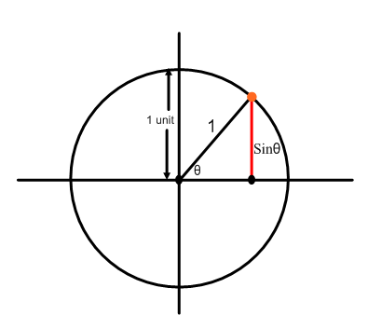

1. 2. 3.

sin =

Such a representation provides the students with a mental tool to think with and, together with the other related representations, allows them to derive and make sense of the various rules and facts associated with the sine function in a way that is rooted in understanding rather than blind memory. The representation reveals the structure.

[N.B. The inclusion of the cosine and tangent on the same diagram gives the student a meaningful and holistic view of the three main trigonometric functions]

**Personal reflection / action planning**

|  |
| --- |
| What is significant, relevant and/or important for me in this feature of teaching for mastery? |

|  |
| --- |
| What aspects of my own practice (and the practice of my department) are already embedded or being developed in this area? |

|  |
| --- |
| What aspects of my own practice (and the practice of my department) do I want to develop now? |

**Big Ideas in Mastery: Variation**

|  |
| --- |
| **Key Messages:**   1. The central idea of teaching with variation is to **highlight the essential features of a concept or idea** through varying the non-essential features. 2. **Variation is not the same as variety** – careful attention needs to be paid to what aspects are being varied (and what is not being varied) and for what purpose. 3. When giving examples of a mathematical concept, it is useful to add variation to emphasise:    1. **What it is (both standard and non-standard examples**);    2. **What it is not**.   When constructing a set of activities or questions it is important to consider what connects the examples; what mathematical structures are being highlighted? Students are encouraged to avoid mechanical practice and, instead, **to practice the thinking process (intelligent practice)** |

**For example:**

Compare Activity A with Activity B:

**Activity A**

**Find the multiplier to increase an amount by:**

1. *i) 50% ii) 40% iii) 60% iv) 20%*
2. *i) 55% ii) 45% iii) 65% iv) 25%*
3. *i) 5% ii) 4% iii) 6% iv) 2%*

Activity B contains a **variety** of questions, changing the amount and the percentage, whereas the questions in Activity A have been constructed to help students notice the place value structure of the multiplier. The careful use of variation in constructing the examples below prompts students to generalise the concept and, hence, helps them to recognise it in unfamiliar, ‘non-standard’ questions and to spot and correct errors (i.e. ‘what it is not’ situations).

**Activity B**

**Increase the amounts using a multiplier:**

*a) £100 by 20% b) £250 by 35%*

*c) £375 by 17% d) £500 by 34%*

*e) £825 by 4% f) £643 by 12½%*

*g) £632 by 120% h) £97 by 0.5%*

**Correct the workings:**

Question Calculator Display

Increase 89km by 70%89 x 1.07

Increase £900 by 34½ %900 x 1.34.5

Increase $35 000 by 12% 35000 x 1.2

**Find the multiplier to increase an amount by:**

1. *i) 2.2% ii) 5.2% iii) 4.2%*
2. *i) 0.2% ii) 0.6% iii) 0.1%*
3. *i) 170% ii) 117% iii) 107%*
4. *i) 107.2%*

**Personal reflection / action planning**

|  |
| --- |
| What is significant, relevant and/or important for me in this feature of teaching for mastery? |

|  |
| --- |
| What aspects of my own practice (and the practice of my department) are already embedded or being developed in this area? |

|  |
| --- |
| What aspects of my own practice (and the practice of my department) do I want to develop now? |

**Big Ideas in Mastery: Variation**

|  |
| --- |
| **Key Messages:**   1. The central idea of teaching with variation is to **highlight the essential features of a concept or idea** through varying the non-essential features. 2. **Variation is not the same as variety** – careful attention needs to be paid to what aspects are being varied (and what is not being varied) and for what purpose. 3. When giving examples of a mathematical concept, it is useful to add variation to emphasise:    1. **What it is (both standard and non-standard examples**);    2. **What it is not**.   When constructing a set of activities or questions it is important to consider what connects the examples; what mathematical structures are being highlighted? Students are encouraged to avoid mechanical practice and, instead, **to practice the thinking process (intelligent practice)** |

**For example:**

Circle the diagram which have a pair of vertically opposite angles marked.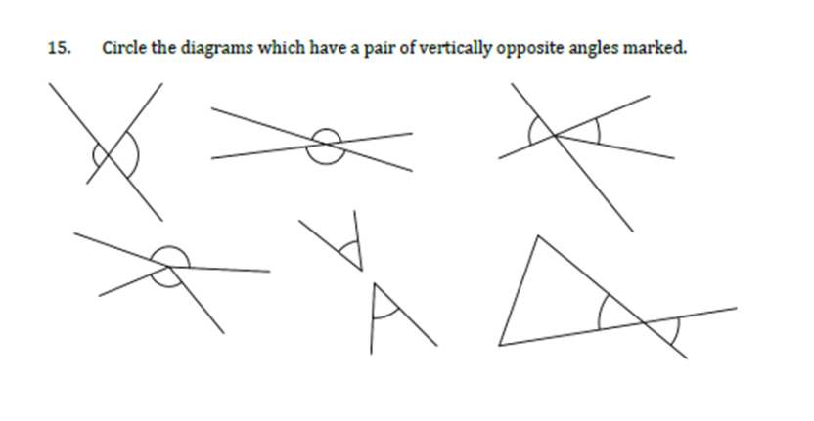

Notice the mixture of standard and non-standard examples as well as examples of what are not vertically opposite angles. The careful use of variation in constructing these examples prompts students to generalise the concept and helps them to recognise it in new and unfamiliar situations.

In this exercise:

Mark the pairs of vertically opposite angles.

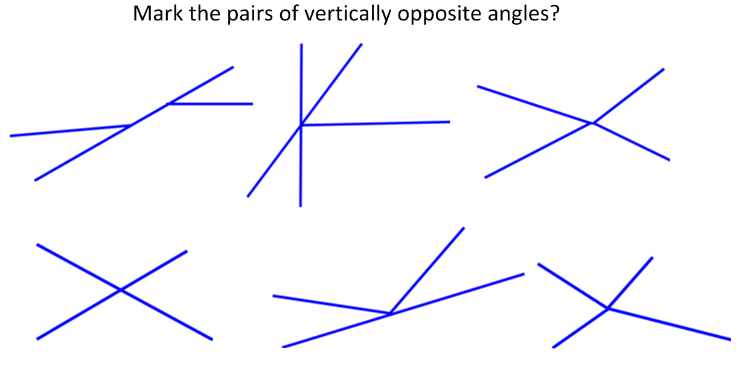

… students are encouraged to go beyond noticing examples and non-examples and to operate on the diagrams and mark in the equal angles. This is practise but not of the mechanical kind where students merely follow a set procedure or experience very standard examples. They are practising the thinking process (thinking all the time “what are vertically opposite angles?; do I really understand the concept?”) and engaging in intelligent practice.

**Personal reflection / action planning**

|  |
| --- |
| What is significant, relevant and/or important for me in this feature of teaching for mastery? |

|  |
| --- |
| What aspects of my own practice (and the practice of my department) are already embedded or being developed in this area? |

|  |
| --- |
| What aspects of my own practice (and the practice of my department) do I want to develop now? |