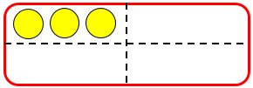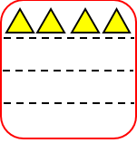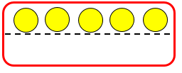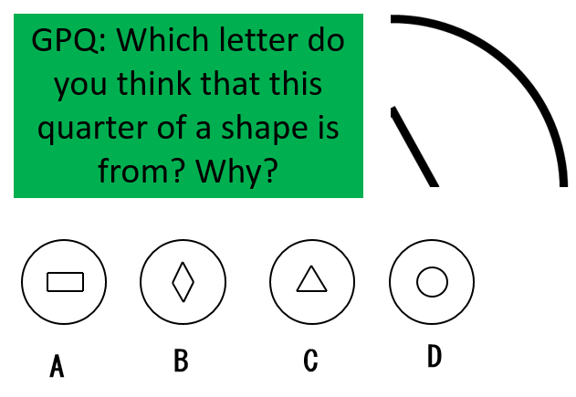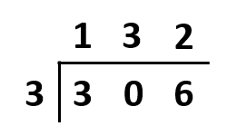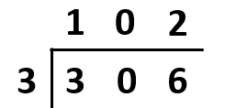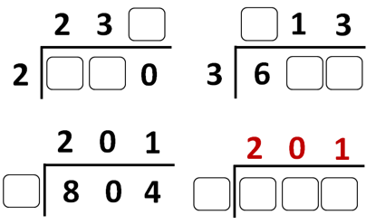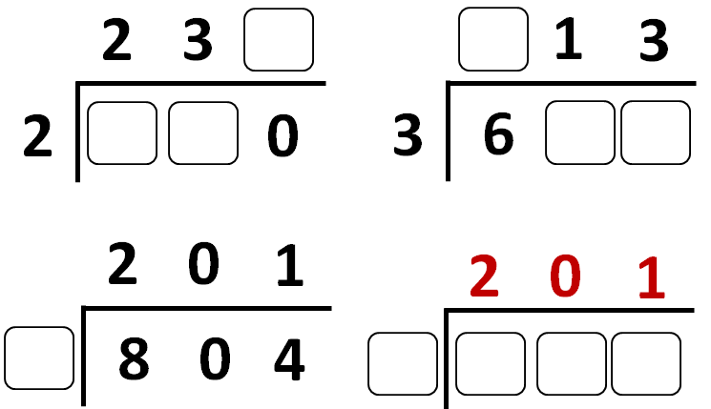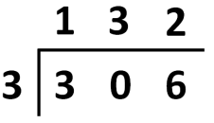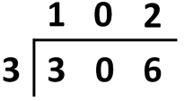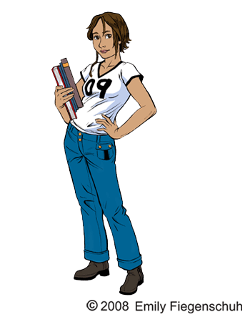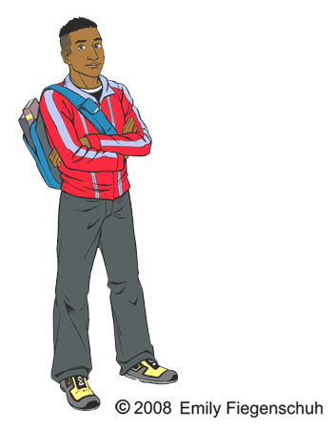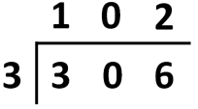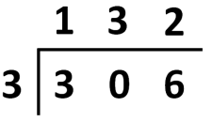

A half of the whole is 5   
The whole is _______  
  
A quarter of the whole is 3  
The whole is _______

A half of a half of the whole is 4   
The whole is _______

If this is a part, what was the whole?

A half of the whole is 5   
The whole is _______  
  
A quarter of the whole is 3  
The whole is _______

A half of a half of the whole is 4   
The whole is _______

If this is a part, what was the whole?

A half of the whole is 5   
The whole is _______  
  
A quarter of the whole is 3  
The whole is _______

A half of a half of the whole is 4   
The whole is _______

If this is a part, what was the whole?

A half of the whole is 5   
The whole is _______  
  
A quarter of the whole is 3  
The whole is _______

A half of a half of the whole is 4   
The whole is _______

If this is a part, what was the whole?

If this is a part, what was the whole?

A half of the whole is 5   
The whole is _______  
  
A quarter of the whole is 3  
The whole is _______

A half of a half of the whole is 4   
The whole is _______

If this is a part, what was the whole?

A half of the whole is 5   
The whole is _______  
  
A quarter of the whole is 3  
The whole is _______

A half of a half of the whole is 4   
The whole is _______

A half of the whole is 5   
The whole is _______  
  
A quarter of the whole is 3  
The whole is _______

A half of a half of the whole is 4   
The whole is _______

If this is a part, what was the whole?

A half of the whole is 5   
The whole is _______  
  
A quarter of the whole is 3  
The whole is _______

A half of a half of the whole is 4   
The whole is _______

If this is a part, what was the whole?

Who do you agree with?

Challenge: How would you explain, and correct the person who is wrong?

What must the missing numbers have been? For the final question, create a question which equals 201.

Challenge: Write a set of instructions for how to solve a division question

What must the missing numbers have been? For the final question, create a question which equals 201.

Challenge: Write a set of instructions for how to solve a division question

201

804 ÷ 4

231

693 ÷ 3

143

286 ÷ 2

423

846 ÷ 2

Can you match the number sentence to the quotient? Show your working!

Explain which number sentence you think is the most difficult. Why?

423

846 ÷ 2

143

201

804 ÷ 4

693 ÷ 3

286 ÷ 2

Can you match the number sentence to the quotient? Show your working!

Explain which number sentence you think is the most difficult. Why?

Who do you agree with?

Challenge: How would you explain, and correct the person who is wrong?