Lesson observation discussions
Context of the lesson 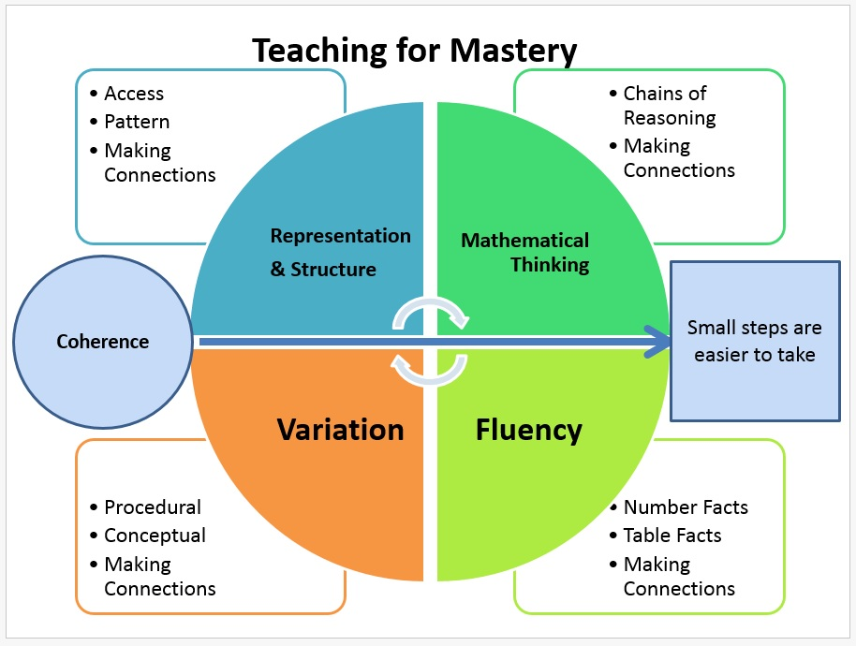

Representation and Structure  How is the mathematics represented and the structure exposed? | Coherence  What were the small steps throughout the lesson?  Where were the big ideas seen? | Mathematical Thinking  How do the children deepen their understanding? When did the children have opportunity to reason and make connections?
Fluency  How are the pupils using known facts and strategies/methods accurately, flexibly and efficiently? |  | Variation  How were the questions carefully crafted to expose key learning? How was the concept represented to secure understanding? What changed? What stayed the same?
Other observations: Questions to ask:

Strategies /Ideas / Techniques I will try as a result of today’s lesson:

With thanks to T. Isherwood
at East Midlands West Maths Hub

